**Simple Origami Problem**

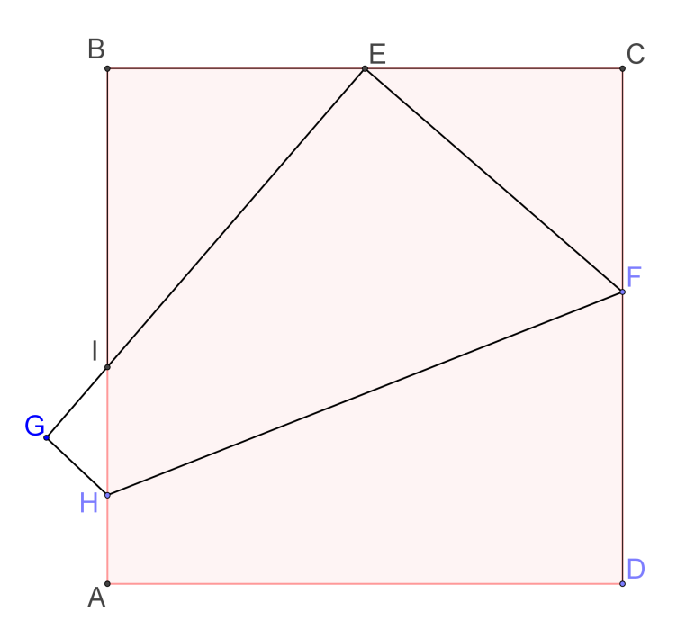You are given a square paper of sides 24.

E is the mid-point of BC.

The piece of paper is folded so that the point D coincides with point E.

HF is the line of folding and point A goes to point G.

By considering the ΔCEF, find all line segments in the diagram.

**Solution**

Let $CF=x$

$CE=\frac{1}{2}×24=12$

$EF=FD=24-x$

By Pythagoras Theorem,

${\left(24-x\right)}^{2}=x^{2}+{12}^{2}$

$x^{2}-48 x+576=x^{2}+144$

$∴x=9$

$CF=x=9$

$EF=FD=24-9=15$

Note that $∠IEF=90°$

$∠BEI=90°-∠CEF=∠CFE$

Hence $∆BEI\sim ∆CFE (AAA)$

$\frac{BE}{CF}=\frac{EI}{FE}=\frac{IB}{EC}⟹\frac{12}{9}=\frac{EI}{15}=\frac{IB}{12}⟹\left\{\begin{matrix}EI=20 \\ IB=16\end{matrix}\right.$

Hence, $IA=24-IB=24-16=8$

Let $GH=HA=y, HI=8-y$

Also, $∆GHI\sim ∆BEI (AAA)$

$\frac{GH}{BE}=\frac{HI}{EI}=\frac{IG}{IB}⟹\frac{y}{12}=\frac{8-y}{20}=\frac{IG}{16}$

$\frac{y}{12}=\frac{8-y}{20}⟹y=3$

Hence, $GH=HA=3, HI=8-3=5$

Also, $\frac{3}{12}=\frac{IG}{16}⟹IG=4$

By Pythagoras Theorem,

${HF}^{2}={AD}^{2}+{\left(FD-HA\right)}^{2}$

${HF}^{2}={24}^{2}+{\left(15-3\right)}^{2}$

$HF=12 \sqrt{5}$

**Yue Kwok Choy**

**13/7/2016**